**Instructions for Completing Form**

**Request Type**

* New User ID – no previous access requested
* Change Access – current User ID requires name, level, division or provider change; additional system(s) access; or remove some system(s) access
* Revoke User ID – current User ID no longer needs access to DMH systems

**Part 1: User Information**

*New User ID Request*

* Complete last name, first name, middle initial, last four digits of SSN, city, phone, email **(must be unique to you and not shared email address)**, and title.
* Select which division is appropriate for your access.
* Select the Provider name in drop down box. (Facility Code/FTP will auto-populate based on what is selected in the Provider field.)
  + If access is needed to additional providers, indicate the additional provider facility codes/FTPs in the Comment field.
* If your Provider isn’t listed, please select “Other”, then type in the Comment field your provider agency name and submit the form so appropriate staff can follow up.

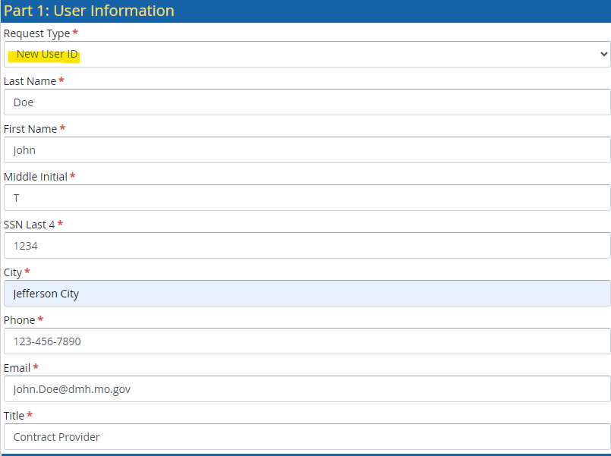

*Change Access Request*

* Complete last name, first name, middle initial, last four digits of SSN, city, phone, User ID, email and title.
* Select which division is appropriate for your access.
* Select the Provider name in drop down box. (Facility Code/FTP will auto-populate based on what is selected in the Provider field.)
* Type in the Change request field what needs to be changed and/or if dual access is needed.

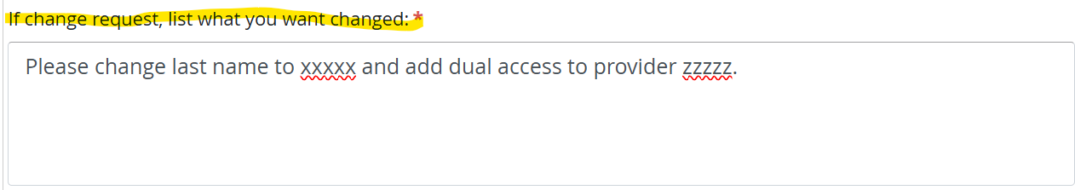

*Revoke User ID Request (to be submitted by LSO)*

* Complete last name, first name, middle initial, last four digits of SSN, city, phone, User ID, email and title for user needing access revoked.
* Select which division access was under for user.
* Select the Provider name in drop down box. (Facility Code/FTP will auto-populate based on what is selected in the Provider field.)

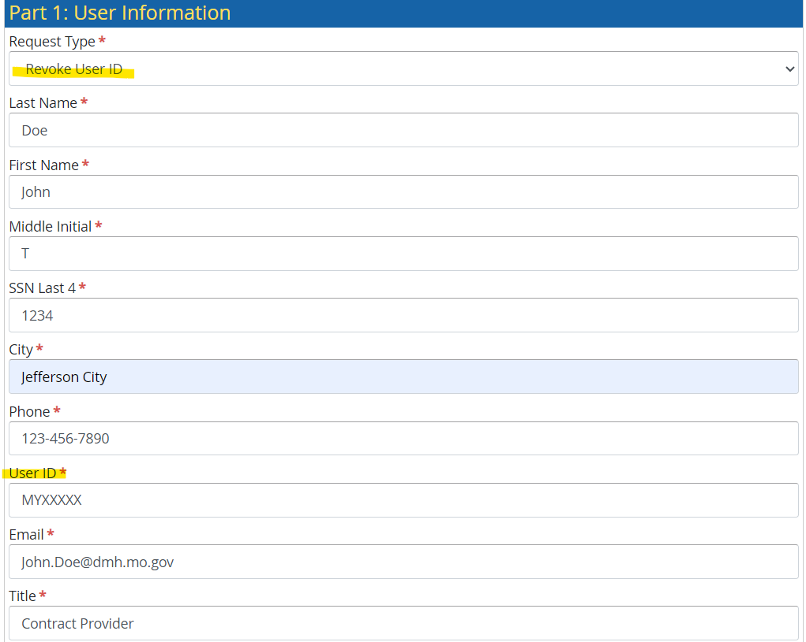

**Part 2: Confidentiality Statement**

* Read the confidentiality statement.
* After reading, select the check box to acknowledge that you have read the statement.
* After everything on the form is complete, sign as indicated and select Submit to send the request to your Local Security Coordinator (LSO).
* The Local Security Coordinator (LSO) will review your submitted form and approve to route the form to the appropriate Division.
* You will receive an email upon submission of your form and additional emails as it moves through the workflow. To ensure that you receive these important notifications, please make sure that @filebound.com domain is ‘allowed’ as a safe sender in your email system.

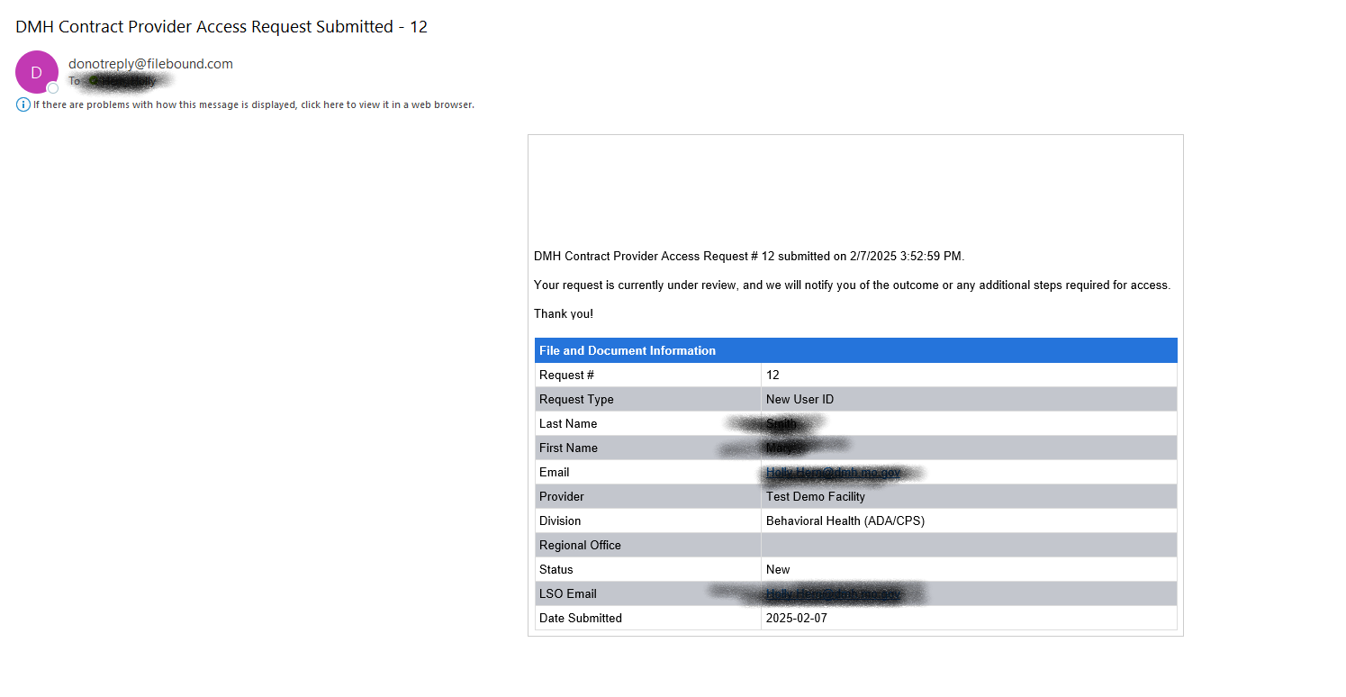

**Part 3:**

The below applications are now requested through DARS ONLINE. On the DMH Portal under the “Security Access Request” section, select the “DMH Application Request System (DARS) – Non-CIMOR Access” link.

NOTE: you will need to have a user id and password in order to access DARS. DARS instructions will be under “Security Access Request” section, labeled “DARS instructions for External Users”.

* Mortality Review (DD RESIDENTIAL PROVIDERS ONLY)
* Consumer Referrals (DD RESIDENTIAL OR TCM PROVIDERS ONLY)
* Integrated Quality Management Functions Database (TCM OR SB40’S ONLY)
* CVS (Approved Behavioral Health Providers ONLY)
* TEDS (Approved Behavioral Health Providers ONLY)

